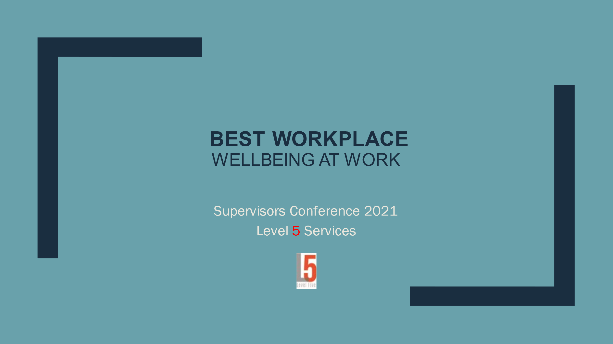

Timothy Denney

**Level 5 Services**

contactlevel5services@gmail.com

**Today’s Objectives:** by the end of today’s work, the learner will have gained:

* Awareness of difficulties & challenges to wellbeing
* An understanding of a culture of wellbeing
* Specific information on behavioral wellness
* Strategies for developing a culture and climate of wellness

**Challenges to wellbeing in the workplace:**

Pandemic challenges

Mental health challenges

Physical, social, emotional, and spiritual challenges

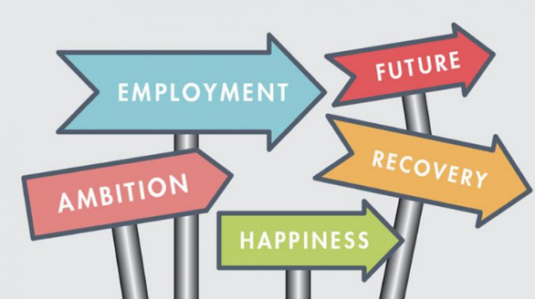

**Where is the hope?**

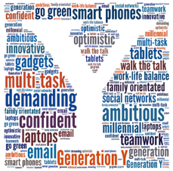**Employee attitudes on wellbeing**

**On positive engagement: why engage employees?**

* The work force…
* Positive engagement…
* Wellbeing strategies…
* Failure to engage…

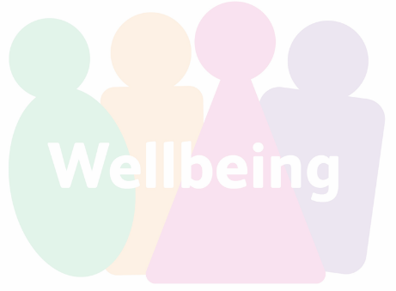**Building a culture of wellness & wellbeing:**

**Wellbeing resources** - build a culture of engagement and genuine concern

* *Vision-casting and training for key influencers*
* *Engagement of workers promotes engagement by workers*

Build a culture of resilience

* *Can be done using in person events and environmental tools*

Build a culture of healthy coping strategies

* *Environmental tools and access to supports*

**Success is possible – four steps.**

1.

2.

3.

4.

**Responding to “un-wellbeing”**

1. Begin engaging the employee immediately
2. 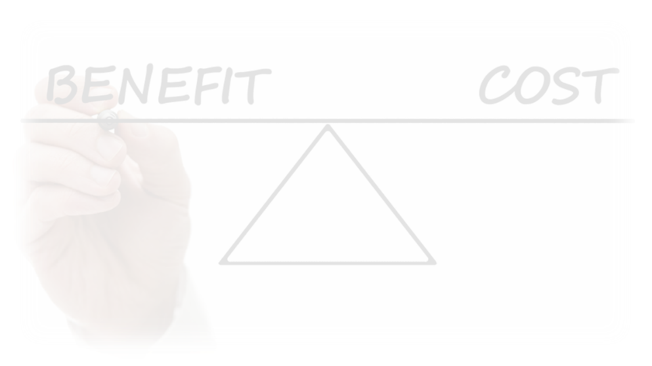Recognize when ADA or FMLA requirements are present
3. Leave diagnosis to professionals - focus on positive behaviors, engagement, accommodations, and recovery strategies
4. Make the culture and climate one of wellbeing
5. Focus on positives, gains, and potential benefits

**The role of leadership**

* Work actively to promote wellbeing in all areas of living, personally and in the enterprise
* Create a wellbeing team to spread the ownership
* Work to create a culture of wellbeing – assume wellness happens
* Focus on positives not problems, on strengths not deficits
* Lean into the conversation about wellbeing and recovery
* Positivity, possibility, proactivity, person-centered
* Focus energy and resources on wellness and wellbeing

**Ideas to get you started:**

Promoting physical health & well-being

1. Get rest – 7.5 to 8 hours average per night.

2. Eat healthy - healthy eating schedule, healthiest snacks, limit use of alcohol and caffeine.

3. Drink water - helps to flush stress chemicals from your system, manage hunger and sleep.

4. Exercise - walk on your breaks, after or before work, on days off, enough to elevate heart rate and breathing

Promoting cognitive health & well-being

1. Limit working hours.
2. Work in teams and limit time working alone.
3. Write in a journal – gratitude, feelings, events, fears, victories
4. Exercise the mind - reading, learning, growing, new thinking and skills.
5. Healthy routines - up early, set goals for the day, connect, keep cleaning.

Promoting emotional health & well-being

1. Practice gratitude - wide range of health benefits, better mood, and reduced stress.
2. Manage media - limit screen time, especially the news cycle.
3. Escape - get out into a green space, get moving, do non-stressful, life-giving things.
4. Debrief emotions - talk to trusted people about your feelings & experiences.
5. Breathing and relaxation techniques

Promoting team health & well-being

1. Create gratitude culture
2. Team huddles on regular basis – make them safe.
3. Encourage “battle buddies.”
4. Wishing Wellness model.
5. Celebrate often, even if it is for nothing – keep it healthy.